DEBUGGING Setup

Requirement :
1. Connect the NXP board with serial JTAG cable to the laptop
2. In Laptop Open the Project in ST32
3.Build the project
4.in the menu bar search for RUN
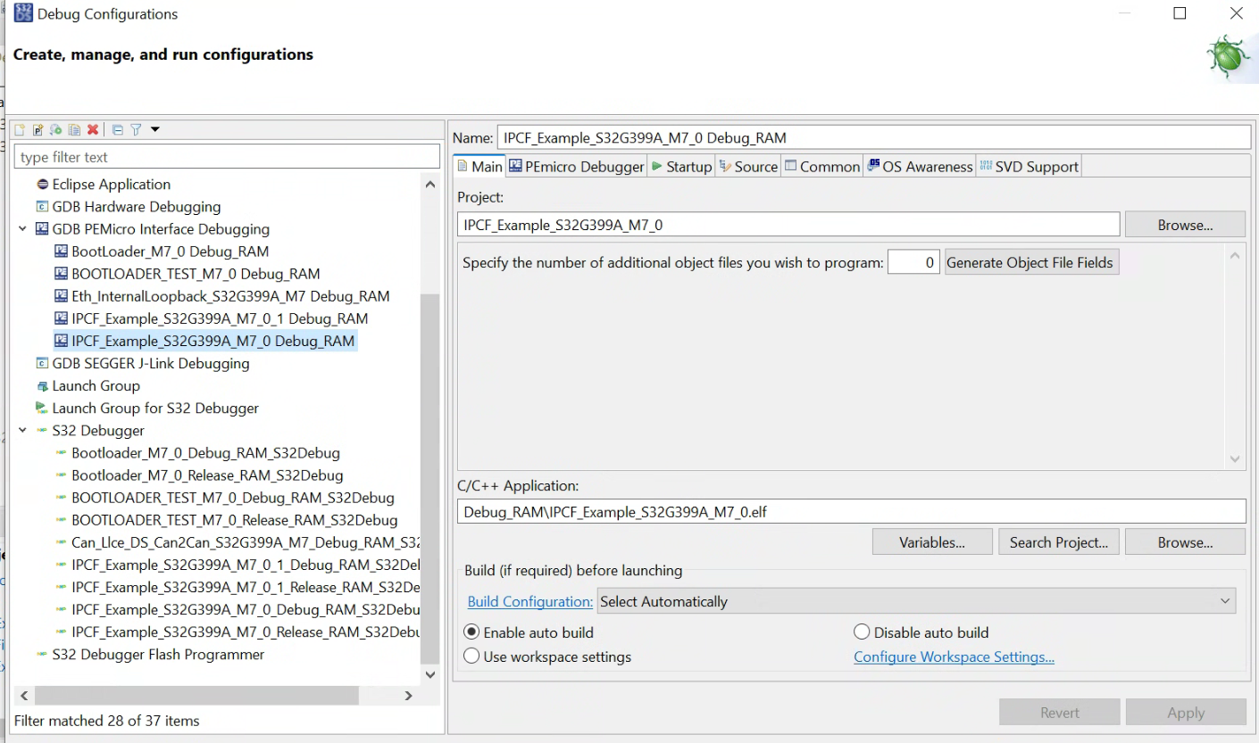
5. inside run Debug As click
6. Follow below steps
7.Open file and give breakpoint
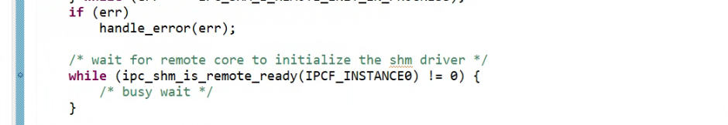

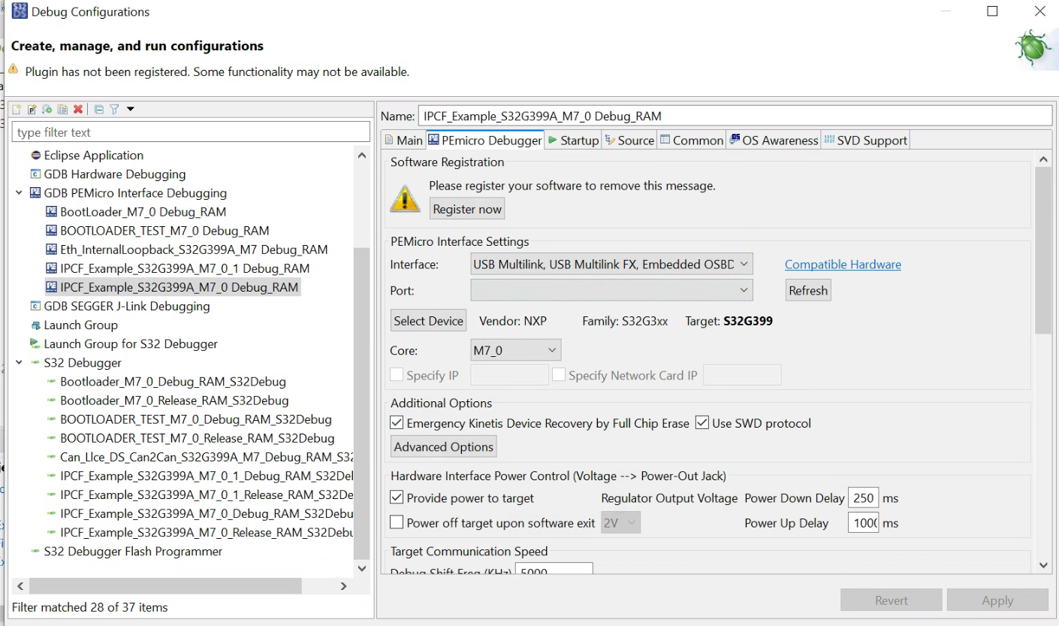
In Startup follow below

